Introduction
We have four sites, ordered by decreasing y-value (because the sweep line moves downward).
Indices follow the same ordering used in your images:
- index 0 → P0 = (7,6)
- index 1 → P1 = (4,5)
- index 2 → P2 = (1,3)
- index 3 → P3 = (8,2)
To compute breakpoints, we use the directrix (the y-position of the sweep line) slightly below the y-coordinate of the site being inserted:
d = y_site − ε
This is necessary because if we use d = y_site, the parabola formula becomes undefined (division by zero).
So all numeric results below are computed as a limit, using a directrix just below the site.

Parabola Formula (used repeatedly)
For a site point ( P=(x_i, y_i) ) and a directrix ( y = d ) with ( d < y_i ):
[
y = \frac{(x-x_i)^2 + y_i^2 - d^2}{2(y_i - d)}
]
A breakpoint between two sites (P_a) and (P_b) is found by solving:
[
\text{Parabola}_a(x) = \text{Parabola}_b(x)
]
This gives two roots; only the root consistent with the left-to-right structure of the beachline is used.
A circle event is determined by the circumcircle of three consecutive sites.
The circle event happens when the sweep line reaches:
[
y_{event} = u_y - r
]
where ((u_x,u_y)) is the center and (r) is the radius.
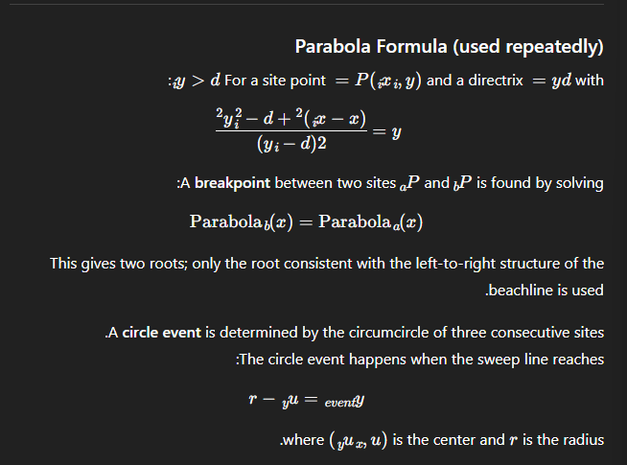

Now: Slide-by-slide full explanation with math + tree interpretation

Slide 0 — Initial State
State:
No SiteEvents have occurred.
The tree is empty — no arcs, no breakpoints, no parabolas.
Nothing to compute here.

Slide 1 — First Site Event: P0 = (7,6)
Directrix: ( d \to 6^- )
After inserting the first site, there is only one arc.
Tree:
A single leaf holding the value:
0
No breakpoints exist because there is only one parabola.

Slide 2 — Insert P1 = (4,5)
Directrix: ( d \to 5^- )
Computing Breakpoint BP(0,1)
Solving the parabola intersection gives two x-roots:
- ( x \approx 3.89695 )
- ( x \approx 4.09705 )
We choose the second one because it lies between the x-positions of P1 (4) and P0 (7).
Valid breakpoint:
[
x \approx 4.09705
]
Tree After Insertion:
- Arc 0 splits into: left-0, new-1, right-0
- A new internal node (0,1) is created
This matches the beachline 0–1–0 in the picture.

Slide 3 — Insert P2 = (1,3)
Directrix: ( d \to 3^- )
P2 is far to the left, so it splits the leftmost arc (which is arc 0).
Computing Breakpoints:
1) BP(0,1):
Roots:
- −9.7522
- 5.7462 ← valid one
2) BP(1,2):
Roots:
- 0.91786
- 1.07914 ← valid
3) BP(0,2):
Roots:
- 0.8755
- 1.1205 ← valid (for left-side geometry)
Only the roots that respect the correct left-to-right order become actual breakpoints.
Geometric Meaning:
P2 cuts the left part of arc 0, creating:
0 → 0, 2, 0
This introduces new breakpoints (0,2) and (1,2), and the new top node becomes (2,1).

Slide 4 — Insert P3 = (8,2)
Directrix: ( d \to 2^- )
P3 appears on the far right, so it splits the rightmost arc, which is arc 0.
Compute BP(0,3):
Two roots; valid one:
[
x \approx 7.93505
]
Geometry now shows beachline order:
0 → 1 → 2 → 1 → 3 → 0

Circle Events (Full Math)
We now compute circumcircles of consecutive triplets to determine circle events.

Circle Event 1 — Triple (P1, P0, P3)
Points: (4,5), (7,6), (8,2)
Circle center:
[
(u_x, u_y) \approx (6.11538,\ 3.65385)
]
Radius:
[
r \approx 2.50739
]
Circle event y-coordinate:
[
y_{event} = 3.65385 - 2.50739 \approx 1.14646
]
This means:
➡️ When the sweep line reaches ( y = 1.14646 ),
the middle arc between these three sites collapses.
This matches the circle event shown in your images.
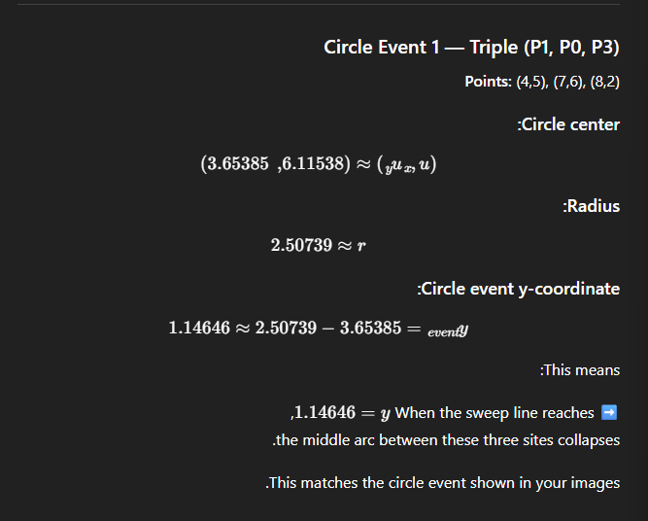

Circle Event 2 — Triple (P2, P1, P3)
Points: (1,3), (4,5), (8,2)
Center:
[
(u_x, u_y) \approx (4.32353,\ 1.26471)
]
Radius:
[
r \approx 3.74928
]
Event y:
[
y_{event} \approx 1.26471 - 3.74928 \approx -2.48
]
This event is below the bounding box,
so it does not appear in the diagram — but it exists mathematically.

Circle Event 3 — Triple (P2, P1, P0)
Event y is extremely low (negative),
so it does not affect the displayed Voronoi formation.

Slide 5 — Beachline After Circle Event
File: /mnt/data/combined_0005.png
Circle event occurred at:
[
d = y_{event} \approx 1.14646
]
The middle arc disappears,
so one leaf of the tree is removed,
and one internal node is replaced.
Meaning:
The beachline simplifies because three arcs meet in one shrinking circle.

Slide 6 — Final Voronoi Diagram
File: /mnt/data/combined_0006.png
After processing all SiteEvents and all CircleEvents,
the remaining breakpoints trace the final Voronoi diagram.
The final tree represents the final set of arcs and edges.
Breakpoints include values like:
- 4.097
- 5.746
- 1.079
- 7.935
- etc.
These correspond to the intersection points of pairs of parabolas at different sweep-line positions.

